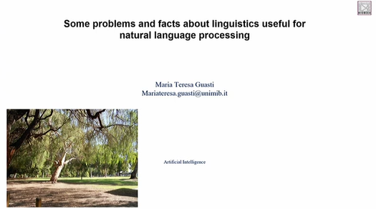

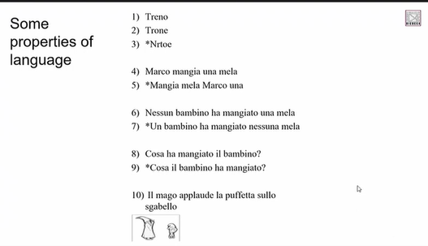

1-2-3 three sequences of letters.
- Treno is a word that has a meaning
- Trone is a legal sequence in italian, but it has no meaning. If tomorrow we need a new word to define a new object and we choose trone every italian would say it is fine. We can invent new words with the sounds and sequences that are legal in italian
- Ntroe same sounds of 1 and 2. Are legal sounds but the rules that put together the sounds are not valid rules (could still be valid for other languages, but not for italian)

You have sounds specific to a language, we have sequences of sounds that are legal (and not legal) in a language (but that can be legal in other languages). We can invent new words, but they are legal in the language, you can not invent whatever you want, must stick to the rule of the language.

- Marco mangia una mela
- Mangia mela Marco una

4) You have a precise order of words. The meaning could be equivalent to other languages, but the order of words is not (turkey says the object before the verb)
5) Sequence of the same words but are ungrammatical. Something that you can not say, it is not a sentence that follows the italian rules

There are rules for putting sounds together and there are rules for putting words together

- Nessun bambino ha mangiato una mela
- Un bambino ha mangiato nessuna mela

Another property that holds in italian, french, portuguese but does not hold in standard english. If you put the negative word in the object position (7) is ok in english, but is not ok in italian (is not possible). When you have a negative word in post-verbal position in english you don’t need to have a negative word in pre-verbal position, while you need in italian

negative sentences have certain properties that vary across languages

- Cosa ha mangiato il bambino?
- Cosa il bambino ha mangiato?

Concern questions asking what, who, which, when, why and how. (8) has a different structure.

- Il mago appluade la puffetta sullo sgabello

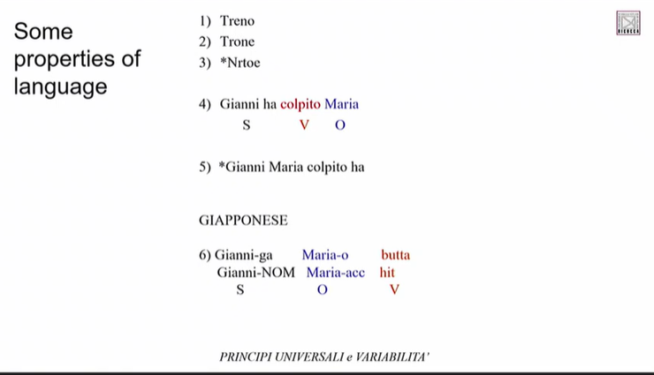

Phonotactic rules: there are rules for the combination of sounds. Every language have a rule to combine words into sentences, you have variability, languages can choose different order (main one subject, object verb)

To test if you are competent in a language, you have to understand jokes. If you do you are are able to do you are on top of the language.

linguaggio:set of properties common that are shared from all language of the word. Used to transmit information, used to make things happens

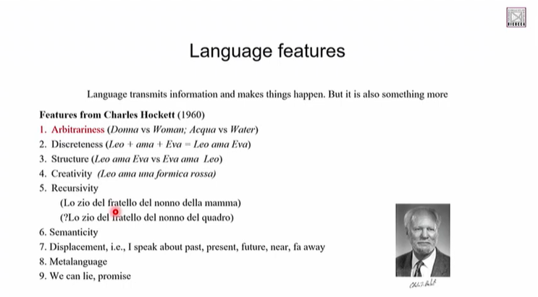
different features that characterize all human languages.

Not just a transmission of information, have some features and a structure. Charles Hockett pointed out some features

---------------------------------------

- Arbitrariness:

